VISITOR MANAGEMENT SYSTEM USING
SERVICENOW
Project Documentation
Project Title
Visitor Management System(VMS) Using ServiceNow
Objective
The objective of the Visitor Management System (VMS) project is to automate and streamline the process of managing visitor registrations within an organization. The application enables visitors to submit visit requests, allows administrators to approve or reject requests, records visitor check-in and check-out activities, sends automated email notifications, generates reports and dashboards, and provides a centralized platform for tracking visitor information.The system improves security, reduces manual paperwork, enhances visitor tracking, and ensures efficient management of visitor activities through an automated workflow built on the ServiceNow platform.

Milestone 1: Project Planning and Environment Setup
Objective
To prepare the ServiceNow development environment and establish the foundation for the Visitor Management System (VMS) application. This phase includes setting up the ServiceNow instance, creating the scoped application, and planning the database structure required for managing visitors and employee hosts.
Step 1: Create Personal Developer Instance (PDI)
- Visit developer.servicenow.com.
- Sign in or create a developer account.
- Request a Personal Developer Instance.
- Wait for instance activation.
- Login using admin credentials.

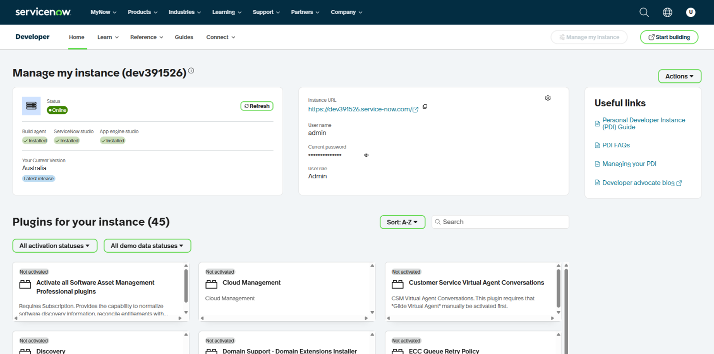
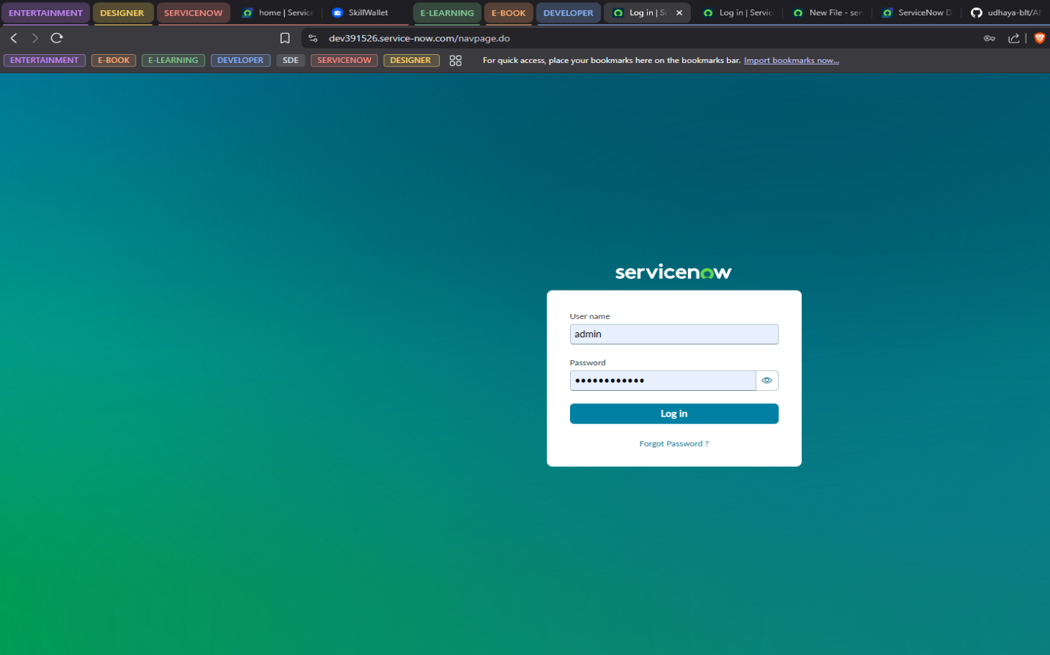

Step 2: Create Scoped Application
Navigation:
System Applications → Studio
- Open Studio.
- Select Create Application.
- Enter:
  - Application_Name:
Visitor Management System
  - Scope: Auto-generated by ServiceNow
- Click Create.
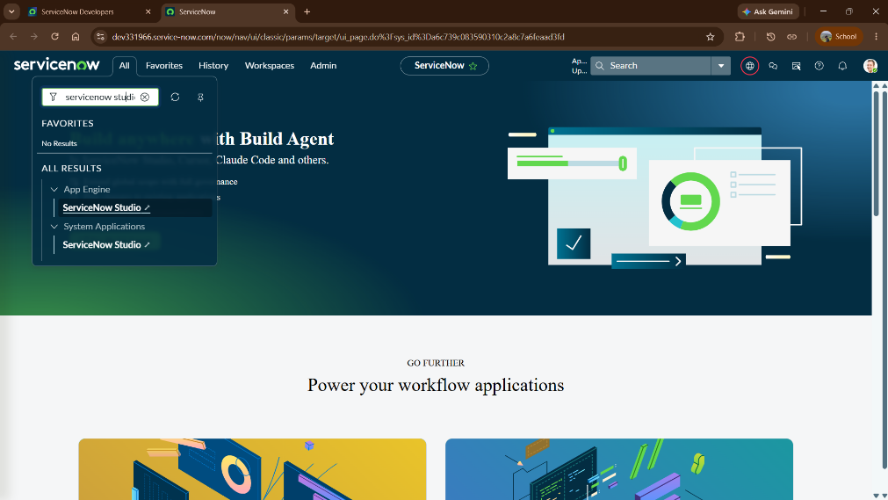
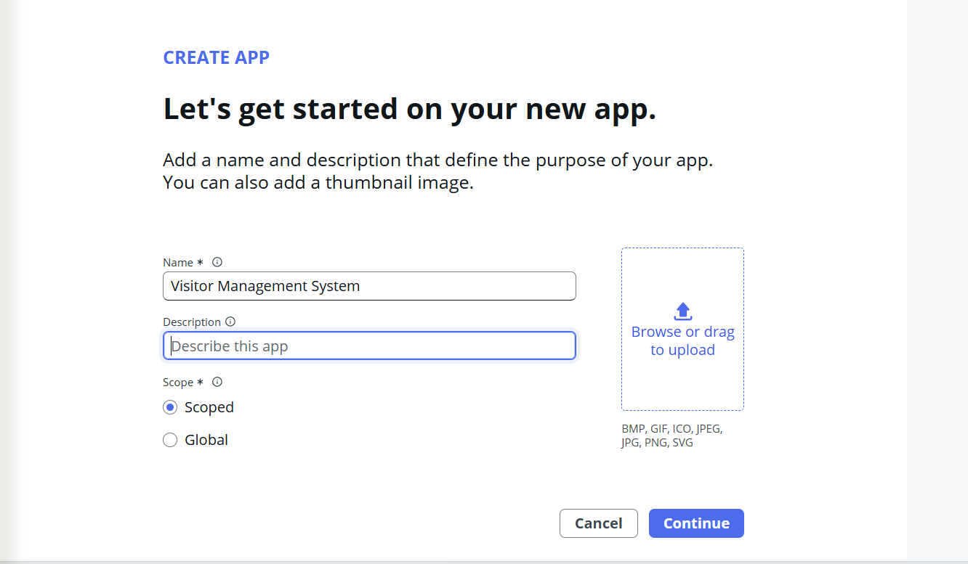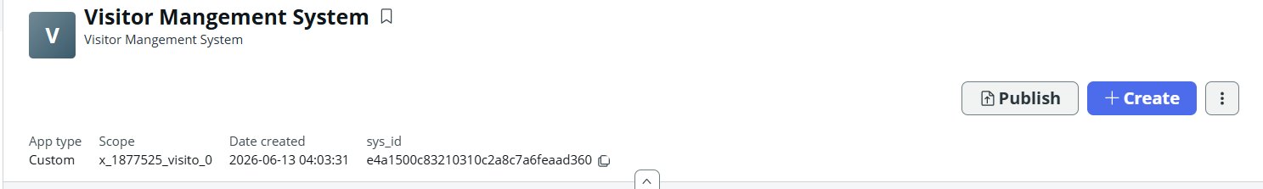

Learning Outcomes
- Understood ServiceNow architecture and application development lifecycle.
- Created and managed a scoped application.
- Configured the ServiceNow development environment.
- Learned ServiceNow Studio fundamentals.
- Understood table creation and relationship management.
- Gained experience in designing custom applications.

Milestone 2: Data Model Design
Objective
Design and implement the database structure for the Visitor Management System by creating custom tables, defining fields, and establishing relationships between employees and visitors.
Step 1: Create Employee Details Table
Navigation:
Studio → Create Application File → Table
Table:
Employee Details
Fields:
- Employee ID
- Employee Name
- Email
- Phone Number
- Department
- Designation
- Location
- Status
Purpose
The Employee table stores information about employees who can act as hosts for visitors.

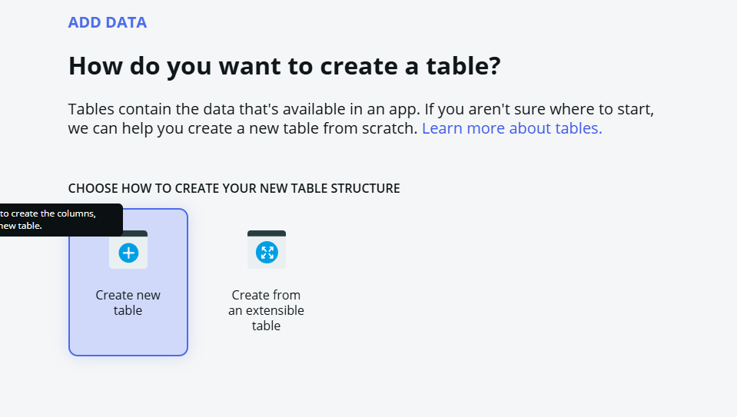

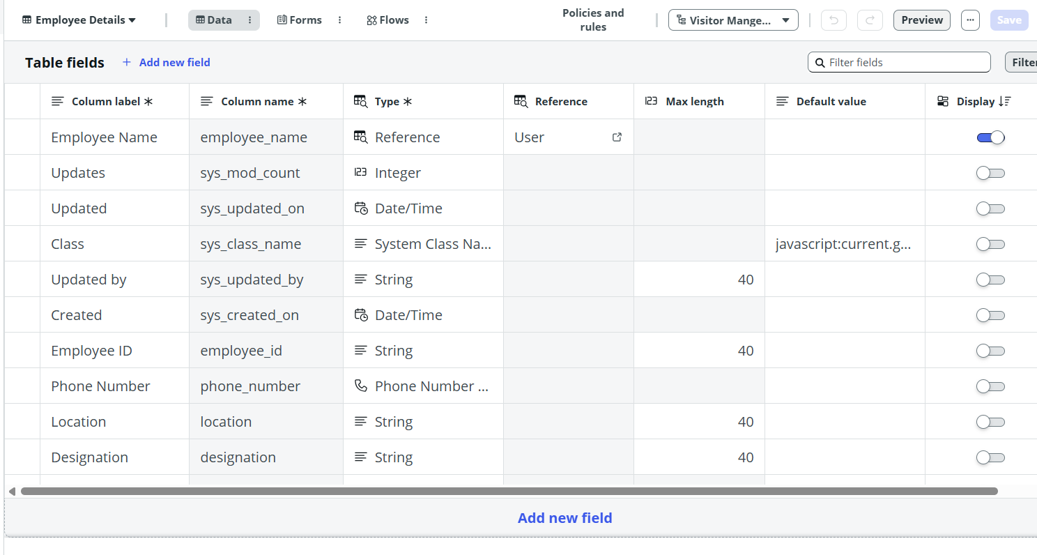

Step 2: Create Visitor Details Table
Create another custom table.
Fields:
- Visitor Name
- Phone Number
- Email
- Company Name
- Visit Date (Date/Time)
- Employee Host
- Purpose of Visit
- Status
- Check In Time
- Check Out Time

Purpose
The Visitor table stores visitor details, visit schedules, approval status, and check-in/check-out information.

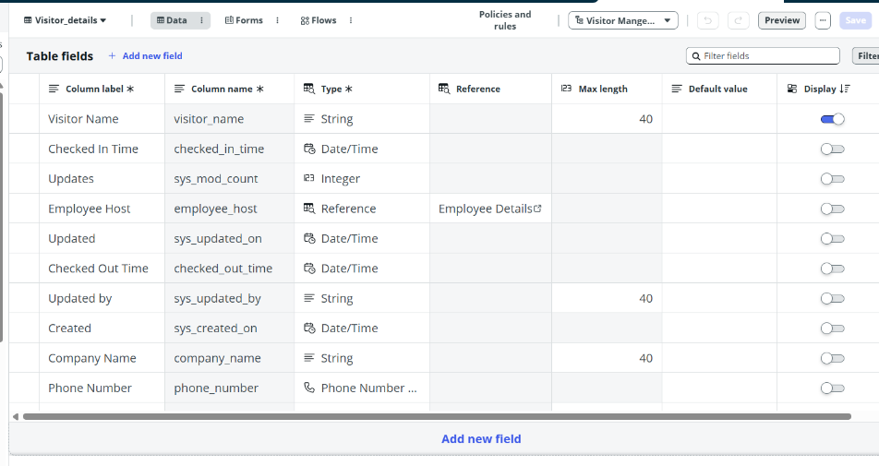

Step 3: Create Reference Relationship
Reference Field
Employee Host
Reference Table
Employee
Relationship
One Employee → Many Visitors
Purpose
This relationship associates each visitor request with an employee host and enables administrators to track visitors assigned to a specific employee.

Step 4: Create Application Modules
Navigation
All → Application Menus & Modules
Modules Created
- Visitors
- Create Visitor Request
- Employees
- Host Visitor Requests
Purpose
The application modules provide easy navigation to different functionalities of the Visitor Management System.
- Visitors – Displays all visitor records available in the system.
- Create Visitor Request – Allows users to submit a new visitor request.
- Employees – Displays employee records that act as visitor hosts.
- Host Visitor Requests – Allows users to view and track their submitted visitor requests.
Deliverable
Application modules were successfully created and configured to improve accessibility and navigation within the Visitor Management System.
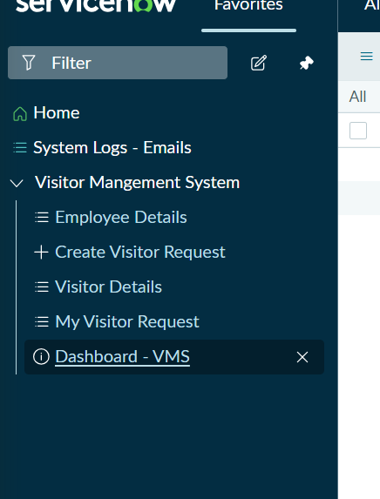

Learning Outcomes
• Created custom tables.
• Extended Task table.
• Created relationships.
• Built navigation modules.

Milestone 3: Business Logic and Security
Objective
Implement business logic, form customization, validation rules, and user interface configurations to automate visitor management processes and improve user experience.
Step 1: Configure Form Layout
Navigation:
Open Visitor Form
Right Click
Configure
Form Layout
Arrange fields in a logical order to improve usability and data entry efficiency.
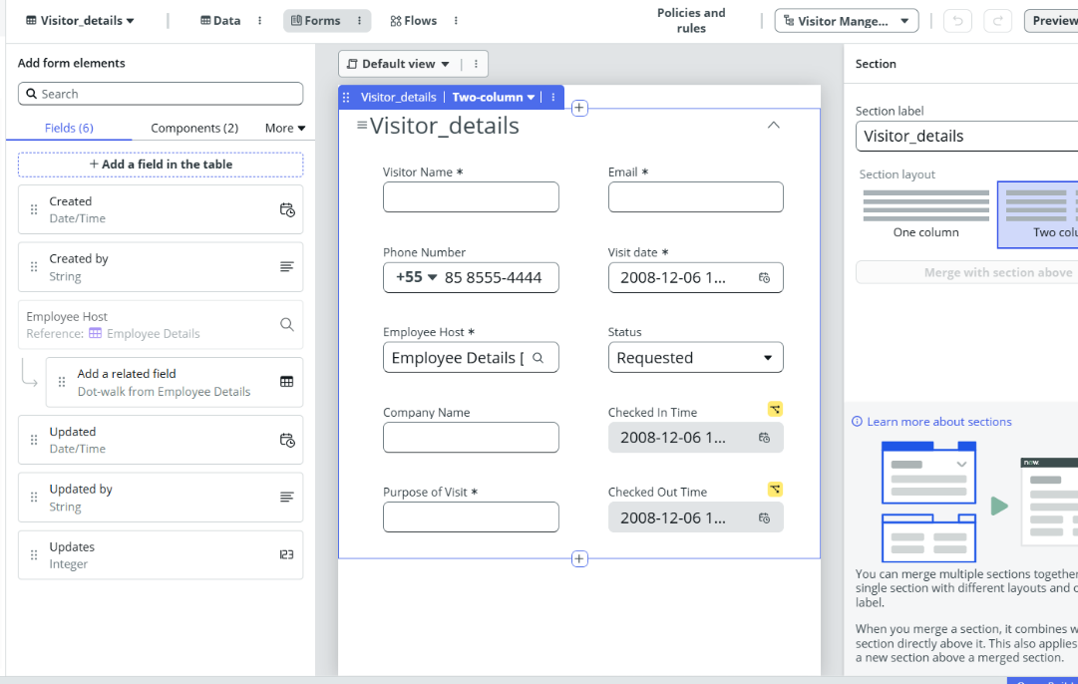
Step 2: Create UI Policies
Purpose
Dynamically control field visibility and improve the user experience by displaying relevant fields based on the visitor's status.
Navigation
System UI → UI Policies
Create New UI Policy

UI Policy 1: Display Check In Time
Table
Visitor
Condition
Status = Checked In
OR
Status = Checked Out
UI Policy Action
- Check In Time → Visible = True
- Check In Time → Read Only = True
Purpose
Displays the Check In Time field after the visitor has been checked in and prevents users from modifying the recorded value.
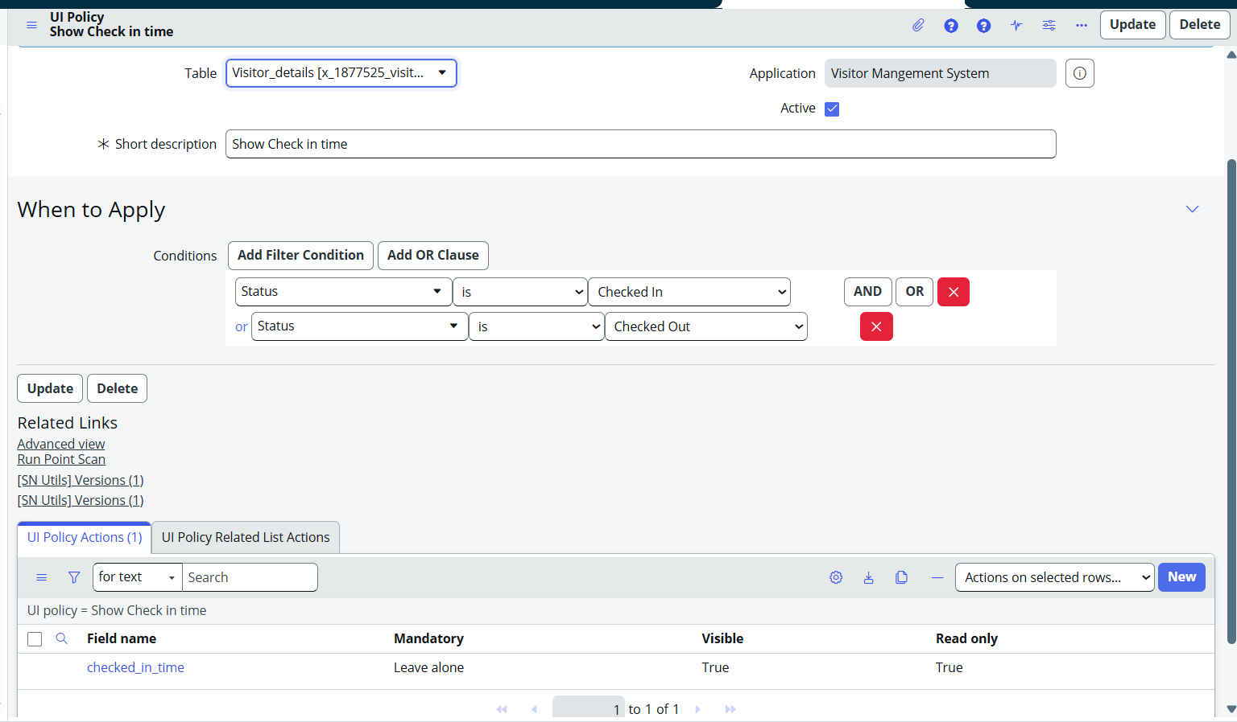
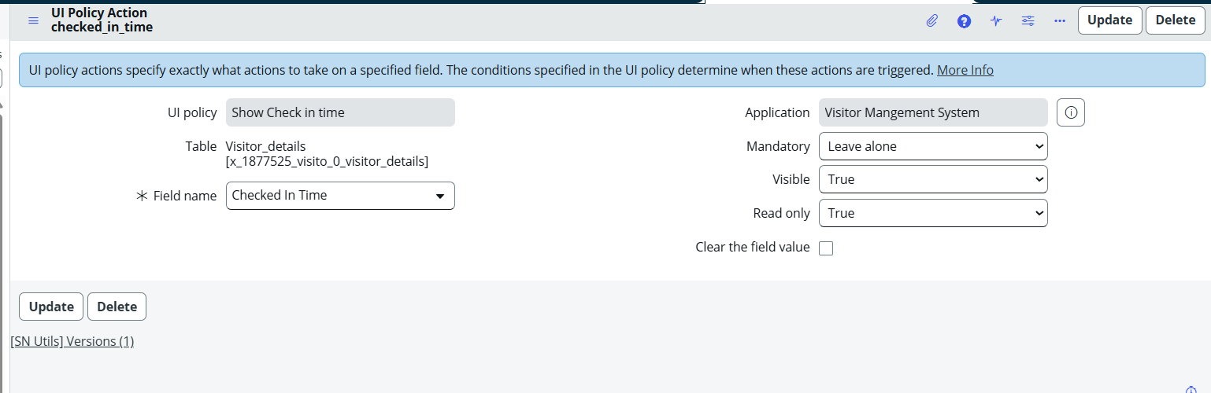

UI Policy 2: Display Check Out Time
Table
Visitor
Condition
Status = Checked Out
UI Policy Action
- Check Out Time → Visible = True
- Check Out Time → Read Only = True
Purpose
Displays the Check Out Time field only after the visitor has been checked out and prevents modification of the recorded timestamp.
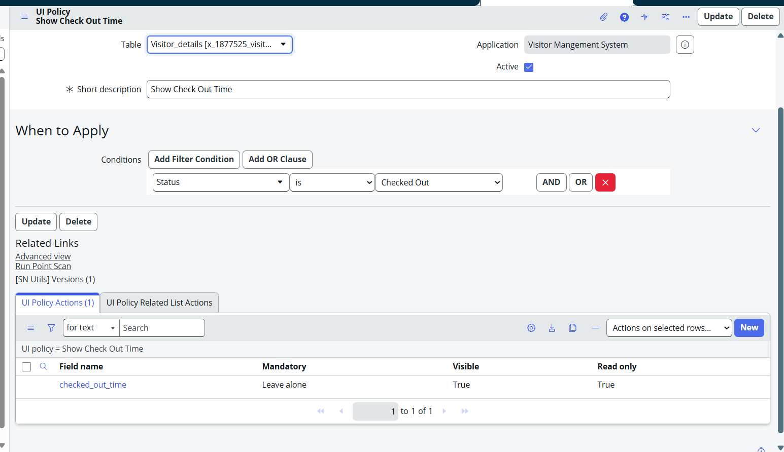
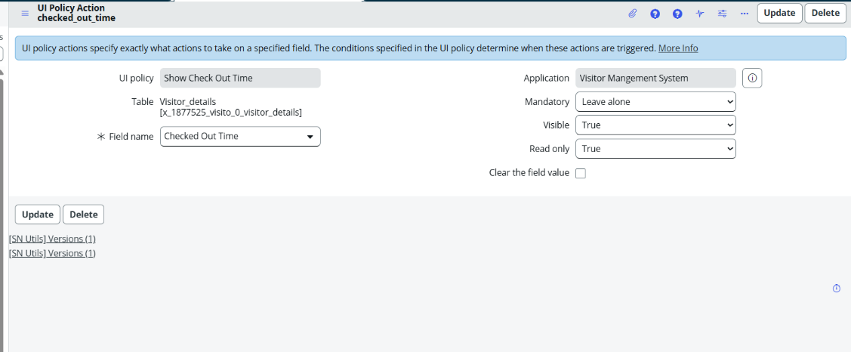

Step 3: Create Custom Role
Navigation:
sys_user_role.list
Role 1:
x_1877525_visito_0.admin
Assign role to Security.
Role 2:
x_1877525_visito_0.user.
Assign role To Employees.
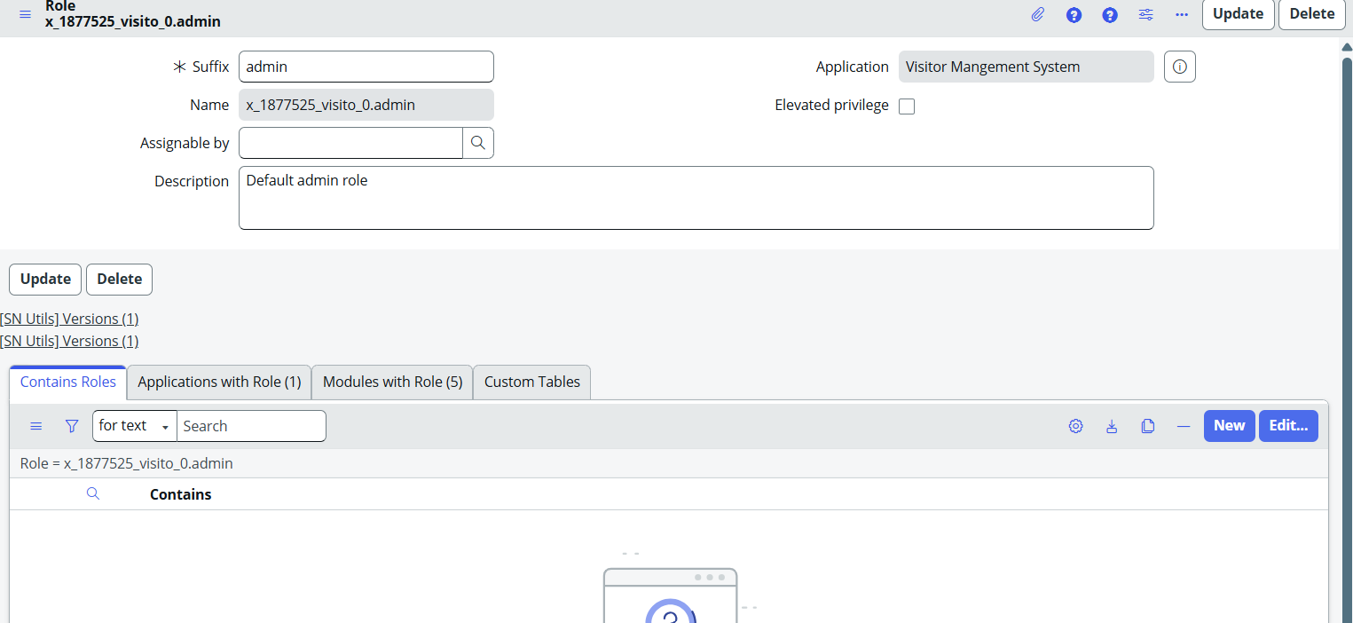
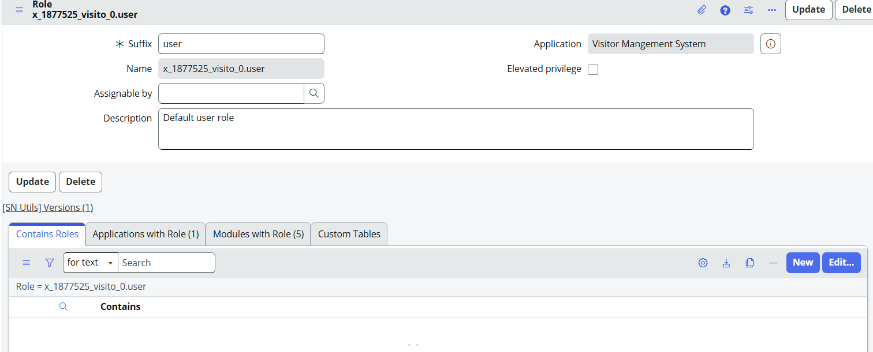
Step 4: Create UI Actions
Purpose
Provide administrators with quick actions to manage visitor requests directly from the Visitor form.
UI Actions Created
- Approve
- Reject
- Check In
- Check Out
Configuration
Each UI Action updates the visitor status and performs the required business logic.
Purpose
These actions automate the visitor approval and visit tracking process, reducing manual effort and improving operational efficiency.
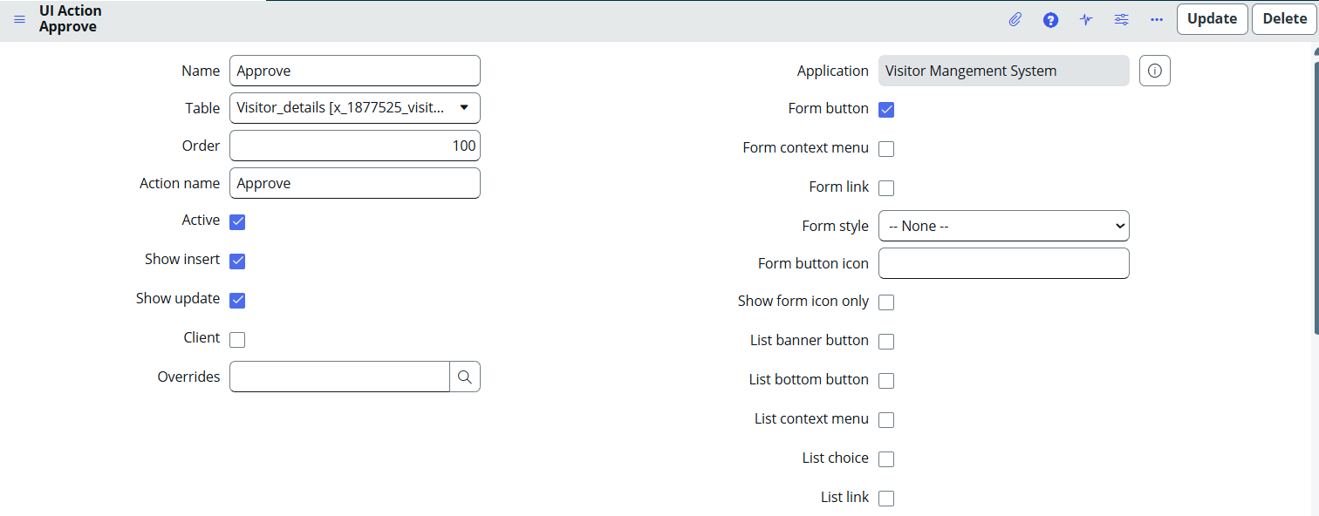

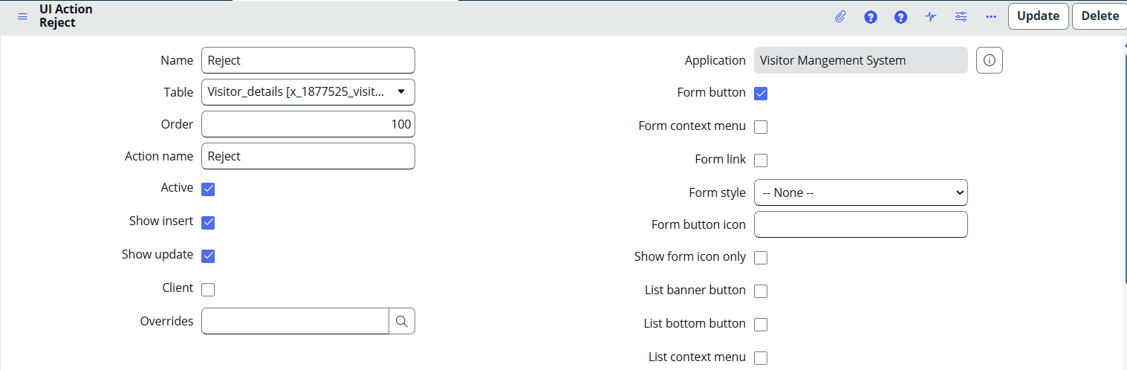
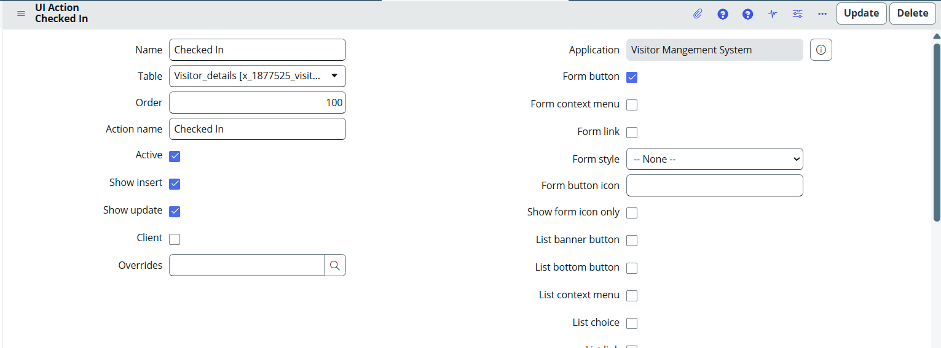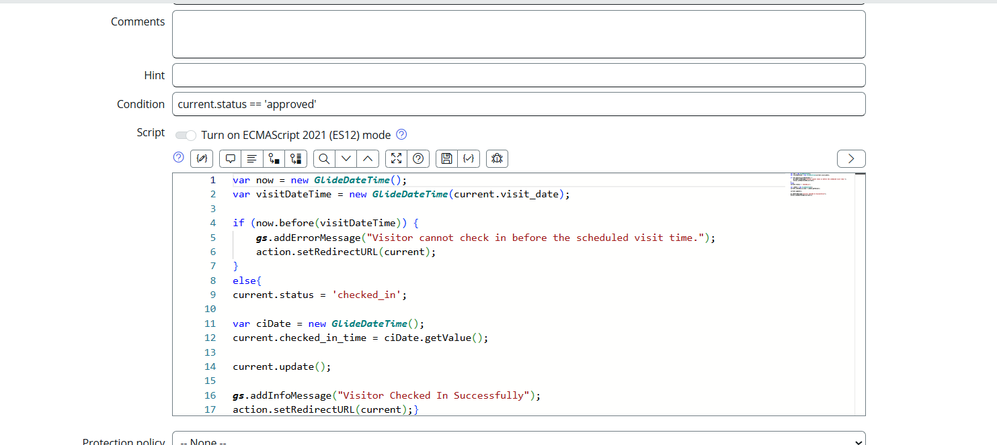

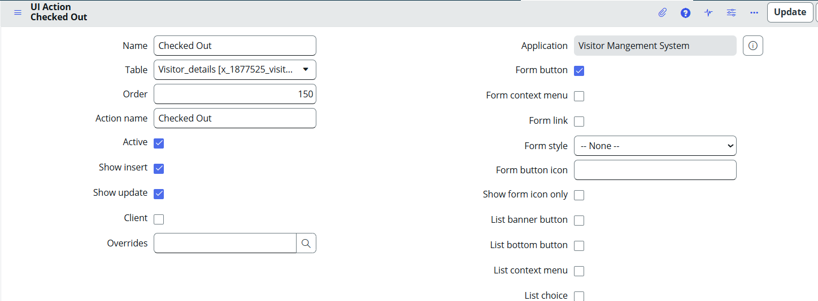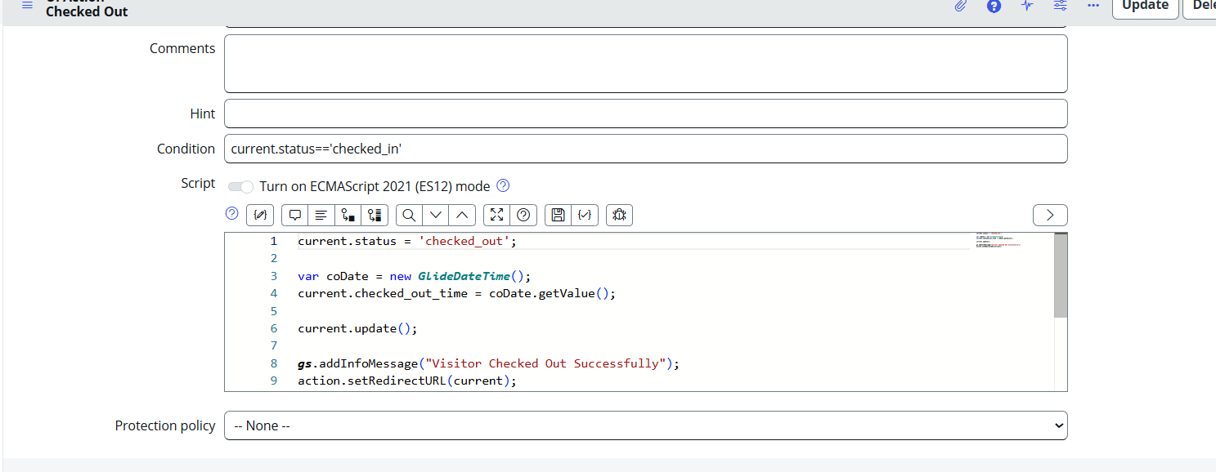

Step 5: Create Client Scripts for Data Validation
Purpose
Validate visitor request details before submission to ensure accurate and valid data is stored in the system.
Navigation
System Definition → Client Scripts
Create New Client Script

Validation 1: Visit Date Validation
The script prevents users from selecting a visit date in the past.
Result
- Past dates cannot be selected.
- Invalid visitor requests are prevented.

Validation 2: Working Hours Validation
The script ensures that visitor appointments are scheduled only during official working hours.
Allowed Time
09:00 AM – 06:00 PM
Result
- Visit requests outside working hours are rejected.
- Only valid appointment times are accepted.
- Improves scheduling and visitor management efficiency.
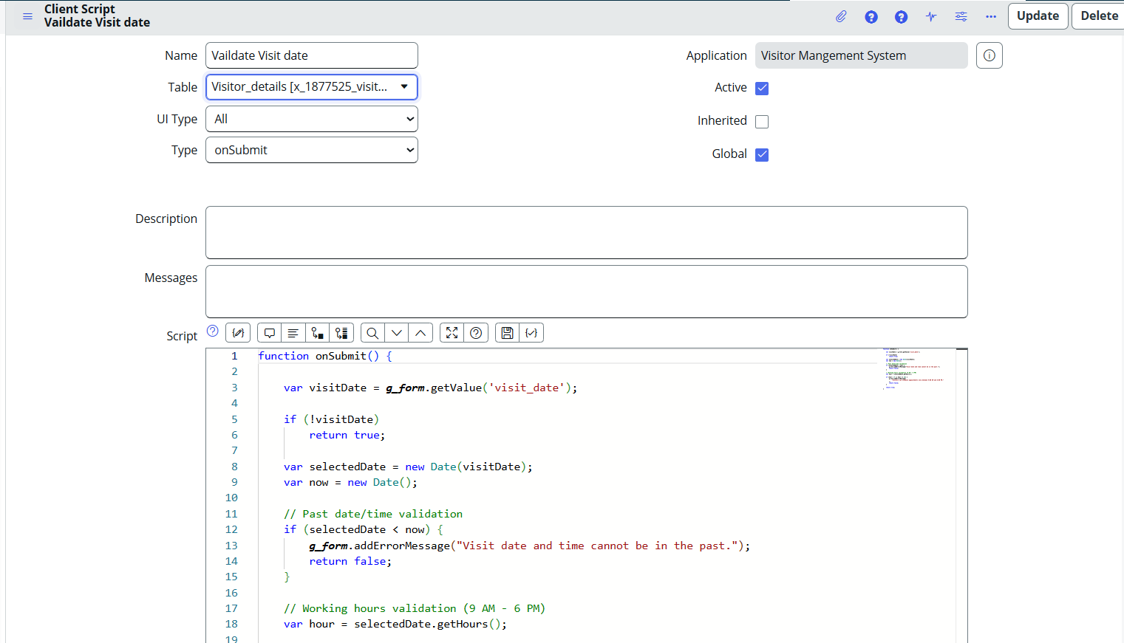

Learning Outcomes
- Learned to create and configure UI Policies.
- Implemented dynamic field visibility and read-only controls.
- Created Client Scripts for date and time validation.
- Applied business logic to enforce working-hour restrictions.
- Developed UI Actions for visitor approval, rejection, check-in, and check-out processes.
- Improved data quality through client-side validation.
- Enhanced user experience by automating visitor management workflows.

Milestone 4: Notifications and Dashboard Monitoring
Objective
Improve communication and visitor tracking by sending automated email notifications and providing real-time dashboard insights.

Step 1: Create Email Notifications Using Flow Designer
Purpose
Automatically notify stakeholders whenever a visitor request is submitted or its status changes.
Navigation
Flow Designer → Create Flow
Flow 1: Visitor Request Submitted
Trigger
Visitor record created
Recipient
Employee Host, Visitor

Email Contents
- Visitor Name
- Company Name
- Visit Date
- Purpose of Visit
- Request Status
Result
The employee host receives an email notification whenever a new visitor request is submitted.

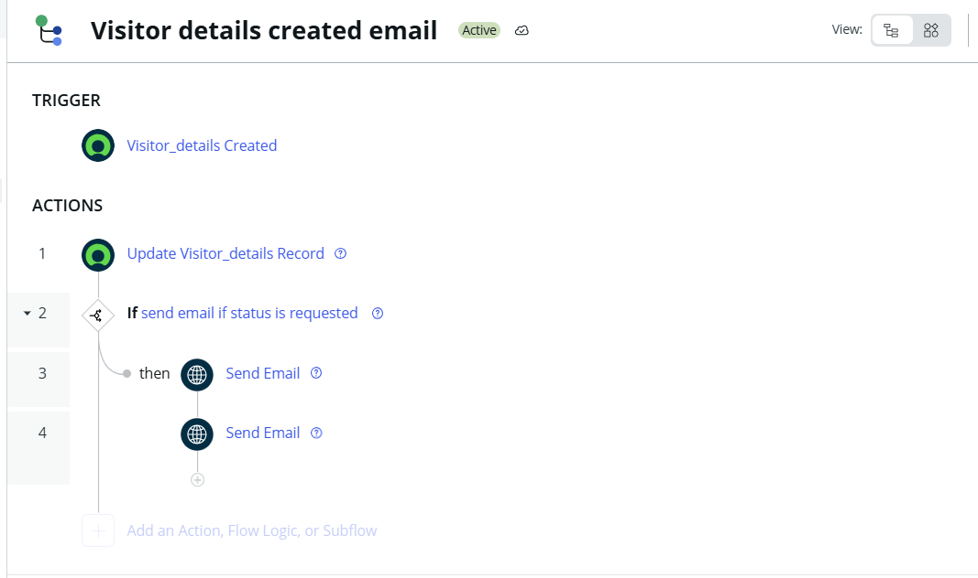

Step 2: Create Status Update Notifications
Trigger
Visitor Status Updated
Recipients
- Employee Host
- Visitor
Email Contents
- Visitor Name
- Visit Date
- Current Status
- Employee Host
Status Notifications
- Approved
- Rejected
- Checked In
- Checked Out
Result
Relevant users receive automated email updates whenever the visitor request status changes.
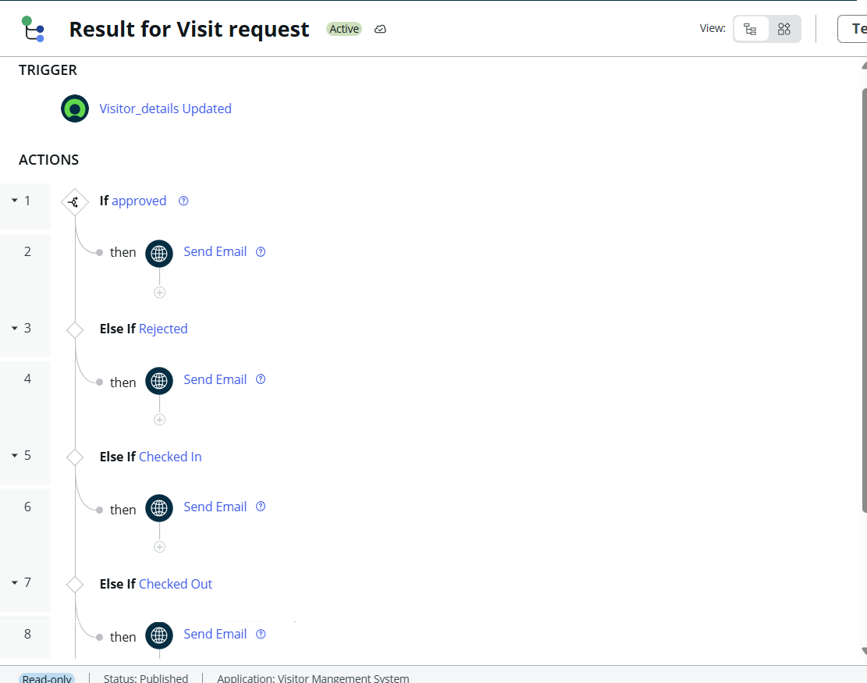

Step 3: Create Visitor Management Dashboard
Purpose
Provide administrators with a centralized view of visitor activities and request statuses.
Navigation
Platform Analytics → Dashboards
Create New Dashboard
Dashboard Name
Visitor Management System Dashboard
Widgets Added
- Total Visit Requests
- Approved Requests
- Rejected Requests
- Checked In Visitors Count
- Currently Checked In Visitors List
- Checked Out Visitors Count
- Checked Out Visitors List
Purpose
The dashboard provides real-time visibility into visitor requests, approvals, rejections, check-ins, and check-outs, enabling efficient monitoring and management of visitor activities.

Result
Administrators can quickly track visitor statistics and view active and completed visits from a single dashboard.

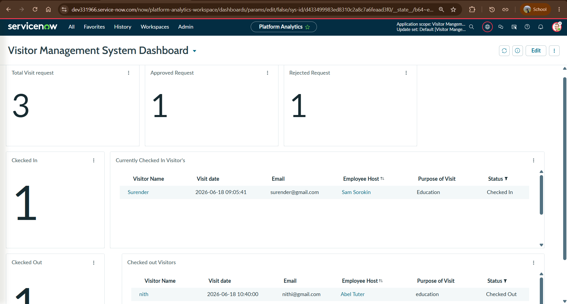

Step 4: Verify Email Notifications
Purpose
Test and verify that email notifications are sent successfully when visitor-related events occur.
Testing Performed
- Submitted a new visitor request.
- Updated visitor status to Approved.
- Updated visitor status to Rejected.
- Performed Check In operation.
- Performed Check Out operation.
Verification
Confirmed that email notifications were delivered to the visitor's registered email address with the correct visitor details and status information.
Result
Email notifications were successfully triggered through Flow Designer and delivered to visitors at each stage of the visitor management process.

Requested:
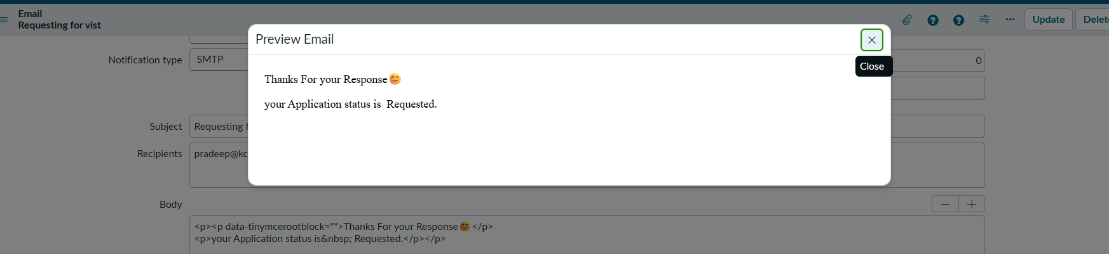

Approved:

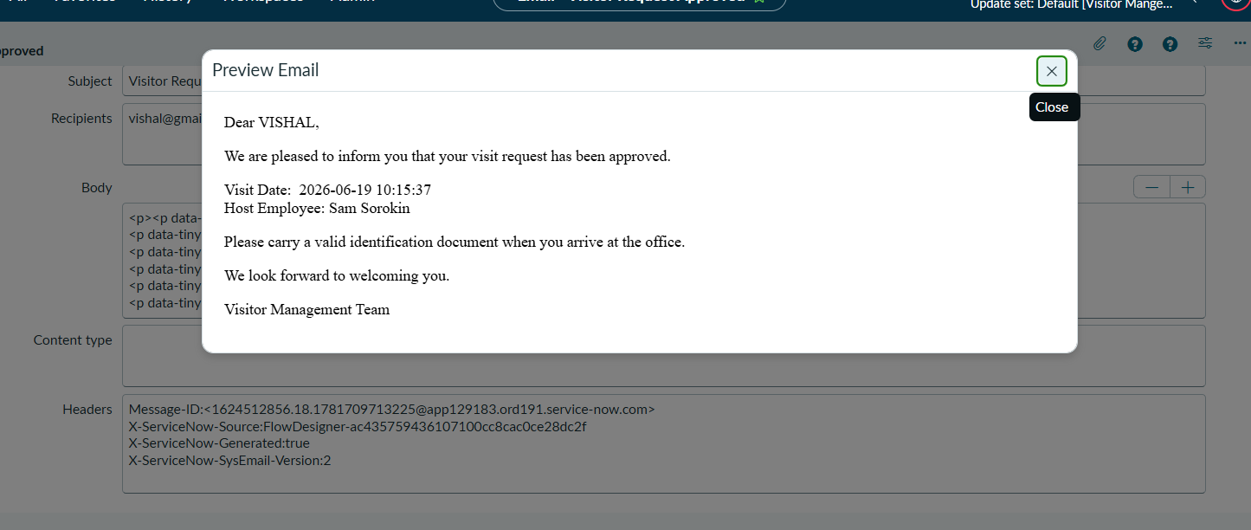

Rejected:
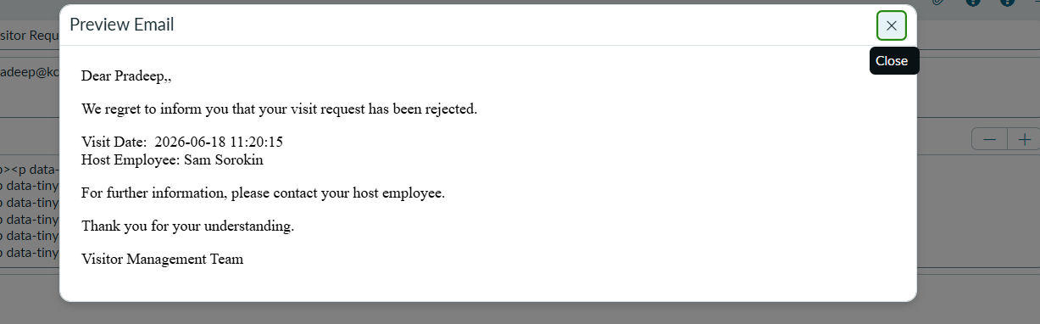

Checked-In: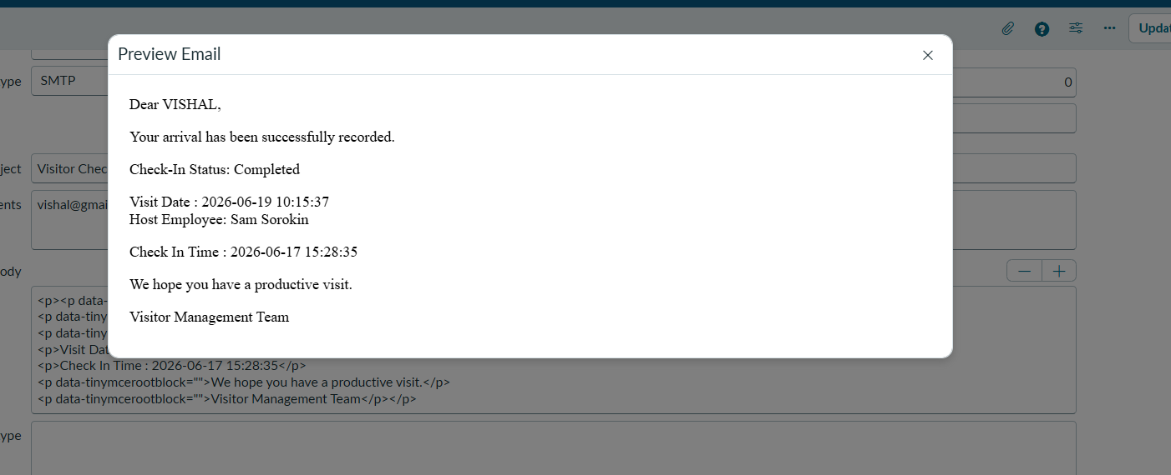

Checked-Out:
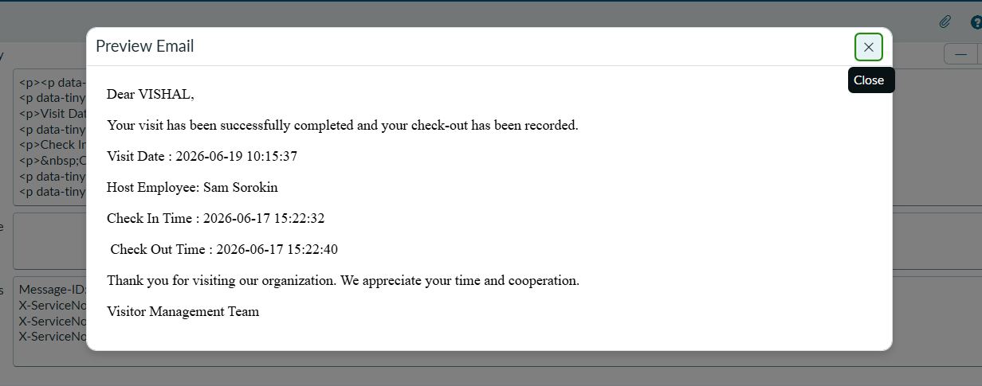

Learning Outcomes
- Created and configured Flow Designer email notifications.
- Verified email delivery and notification processing.
- Designed and developed a Visitor Management Dashboard.
- Configured dashboard widgets for visitor monitoring.
- Learned real-time tracking and visualization of visitor activities.
- Improved reporting and analytics through dashboard insights.

Final Testing Checklist
✓ Scoped Application
✓ Employee Table
✓ Visitor Table
✓ Reference Relationship
✓ Application Modules
✓ Form Layout Configuration
✓ UI Policies
✓ Client Scripts
✓ Working Hours Validation
✓ Approve UI Action
✓ Reject UI Action
✓ Check In UI Action
✓ Check Out UI Action
✓ Flow Designer Notifications
✓ Visitor Management Dashboard
✓ End-to-End Testing
✓ Application Export

Conclusion
The Visitor Management System (VMS) successfully automates the process of managing visitor requests using the ServiceNow platform. The application enables visitor registration, approval and rejection of requests, visitor check-in and check-out tracking, automated email notifications, and dashboard-based monitoring. The project demonstrates key ServiceNow concepts including scoped application development, custom tables, reference relationships, client scripts, UI policies, UI actions, Flow Designer automation, and dashboard creation. The solution improves visitor tracking, reduces manual effort, enhances communication, and provides real-time visibility into visitor activities.

Future Enhancements
- Multi-level approval workflow.
- Visitor badge generation and printing.
- QR Code based visitor check-in.
- Visitor self-service portal.
- Mobile-friendly interface.
- Visitor history and audit tracking.
- Advanced dashboard analytics and trends.
- Integration with attendance or access control systems.
- Automated visitor pass expiration notifications.
- AI-assisted visitor insights and analytics.

